Grading for the **PURPLE TEAMS** **SE Team Project with Line Numbers & SRS & Web Site Design** **& TEAM? web site** **& Team Project Report** Deliverables:

**PURPLE DELIVERABLES 20% OUT OF 30%**

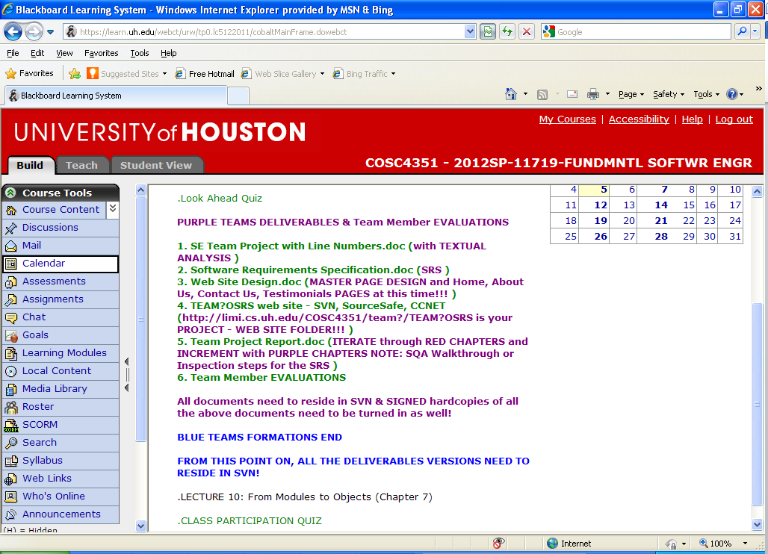

1. SE Team Project with Line Numbers.doc (with TEXTUAL ANALYSIS)

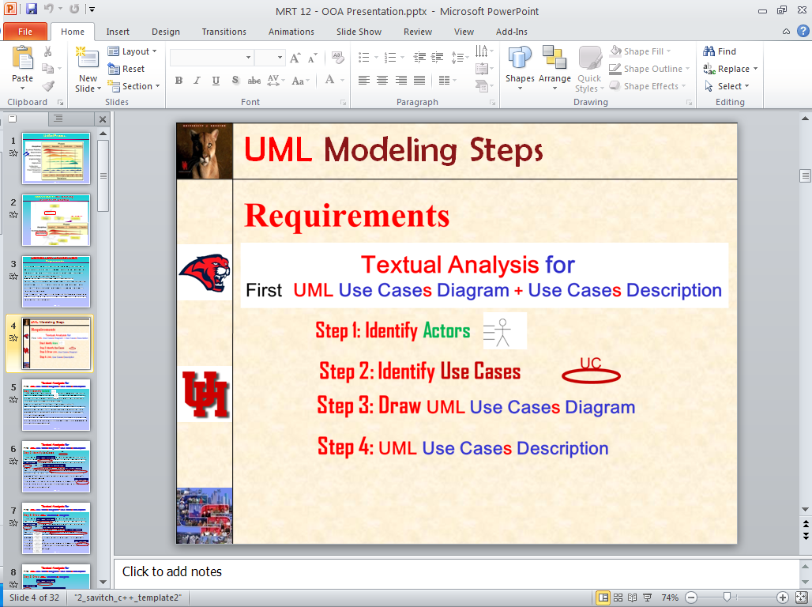

(**Note: YOU CAN modify this Requirements Document to make it clearer**!)

2. Software Requirements Specification.doc (**SRS**) **- (out of 100 points) - SOFTWARE REQUIREMENTS SPECIFICATIONS**

1. **Textual Analysis** against the “**SE Team Project with Line Numbers.doc**” **– 20 points**

**(Forward Engineering Traceability, from SE Team Project with Line Numbers.doc to SRS.doc)**

1. **Table with Labeled Use Cases UC?s – 20 points**

**(Backward Engineering Traceability, from SRS.doc SE to Team Project with Line Numbers.doc)**

1. **UML Labeled Use Cases Diagram + Labeled Use Cases Description – 20 points**
2. **Table with Labeled Requirements R?s – 20 points**

**(Backward Engineering Traceability, from SRS.doc SE to Team Project with Line Numbers.doc)**

3. Web Site Design.doc **-** **(out of 100 points)** **- WEB SITE DESIGN**

(MASTER PAGE DESIGN and Home, About Us, Contact Us, Testimonials PAGES at this time!!!)

1. **Master Page Design** **– 30 points**
2. **Home Page (using the Master Page Design)**
3. **About Us (using the Master Page Design)**
4. **Contact Us (using the Master Page Design)**
5. **Testimonials (using the Master Page Design)**

4. TEAM?O**XX**S web site - SVN, SourceSafe, CCNET **- (out of 100 points) - TEAM WEBSITE IN SVN**

(http://limi.cs.uh.edu/COSC4351/team**?**/TEAM**?**O**XX**S is your PROJECT - WEB SITE FOLDER!!!)

**Your TEAM?OSXXS PROJECT (you need to use an IDE, please refer to the list of IDEs/OO Implementation Languages) needs to be in SVN in the folder above.**

**PLEASE, do not name your website anything else BUT TEAM?OXXS!**

5. Team Project Report.doc **– (out of 100 points)** **- TEAM PROJECT REPORT - PURPLE**

(ITERATE through RED CHAPTERS and INCREMENT with PURPLE CHAPTERS NOTE: SQA Walkthrough or Inspection steps for the SRS)

1. Iterate through the **RED TEAM CHAPTERS** **per FEEDBACK provided by the INSTRUCTOR** **– 20 points**
2. Increment with **PURPLE TEAM CHAPTERS** **– 60 points**
3. As per **Lecture 6 on Testing** “**SQA** should **write about their team’s Walkthrough or Inspection** steps for the **SRS** together with **Metrics**“ **– 20 points**

6. Team Member Evaluations.doc **- PURPLE TEAM EVALUATIONS**

(ONLY HARDCOPY, turned in by the TEAM LEADER. Score from 0 to 10 for ALL **PURPLE** TEAM DELIVERABLES)

Software Engineering **Semester** **Year**

Team**?**O**XX**S **Team Member Evaluations**

**Deliverables: PURPLE TEAMS**

1. **SE Team Project with Line Numbers.doc (with Textual Analysis)**
2. **Software Requirements Specification.doc (SRS)**
3. **Web Site Design.doc (Master Page)**
4. **TEAM?OSGS website – SVN, CCNET, Web Server**
5. **Team Project Report.doc (iterate RED chapters & increment PURPLE chapters)**

|  |  |  |
| --- | --- | --- |
|  | **Name** | **Evaluation (0..10)** |
| **Team Leader** |  |  |
| **SQA** |  |  |
| **Team Member** |  |  |
| **Team Member** |  |  |
| **Team Member** |  |  |
| **Team Member** |  |  |
| **Team Member** |  |  |